Studio Practice Assignment 1

# Introduction

This report is an analysis of the game Swords of Potions, which is a third person freemium, adventure / activity game. The game is set in the medieval age with the Main Character being a young merchant who owns a shop in a kingdom.

The objective of the game is to increasing the size and reputation of the shop by making in game profit by using methods used in a real retail outlet which are selling in game items to customers throughout the kingdom.

# Marketing

As the game is browser based and free to use there is little point in mass media advertising, which would be far too expensive to be covered by any revenues generated from within the game, instead this game is marketed via several online games companies and websites like Kongregate, Armour Games and Edgebee plus many more.

The developer may have had to pay an initial fee for this so is reliant on good reviews on the game forums, social media, and word of mouth. This means the game needs to be slightly addictive and challenging to encourage this and ensure users repeatedly return to the game.

Responding to both positive and negative feedback with updates, patches and enhancements add further media activity, further marketing the game through community building, evidence of which can be seen from 10th November 2013 update which allowed players to increase the capacity size of their recourse bins (Kronoan 2013).

# Revenue

This game relies on three types of revenues;

1. The game draws players to various websites from which the developer may receive some pay-per-click revenue.
2. There are in game adverts which again may produce more pay-per-click revenue.
3. There are in game purchases which the developer may only gain a portion of due to the administration cost charged by the hosting website.

# In Game Mechanics

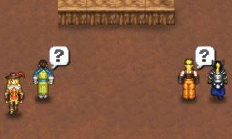One mechanic in the game is customer browsing, where sometimes a customer enters the shop but does not buy anything, for some players this is a waste of time and quote “somewhat of an annoyance” (A fandom User 2013), whereas others (Xiviar 2013) believes it is an excellent idea because it is very realistic as in the real world not everyone comes into a shop to buy something.

Further to this Xiviar suggests leaving this person alone and then they may want to buy something later by showing a question mark icon above there avatar as show in figure 1, as opposed to approaching them where there is a chance they will get annoyed and put off buying anything and possibly slightly effecting the player’s reputation.

As the objective for growth is best achieved by successfully selling products to customers so they will spread the word throughout the kingdom, allowing the player to move to larger premises and even into the citadel mastering who to approach and who to ignore is a great challenge to set players.

Figure 1

Another mechanic in the game that drives revenue is the in-game resources.

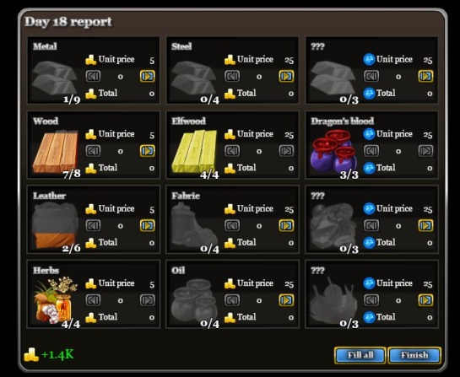

A customer may select an item they wish to purchase such as a knife which requires one unit of steel to build. Once the player constructs the knife one unit of steel is taken away from the available resources. The other in game resources are wood, Elfwood, etc, all of which have different properties and costs, with the more uncommon ones costing considerably more. This is shown in figure 2. Kronoan believes that they are too expensive and quote “it’s not worth it” and “the tokens can be better spent making recipes”. (Kronoan 2013).

Others disagree, which shows this element of the game is successful in generating media noise.

Figure 2

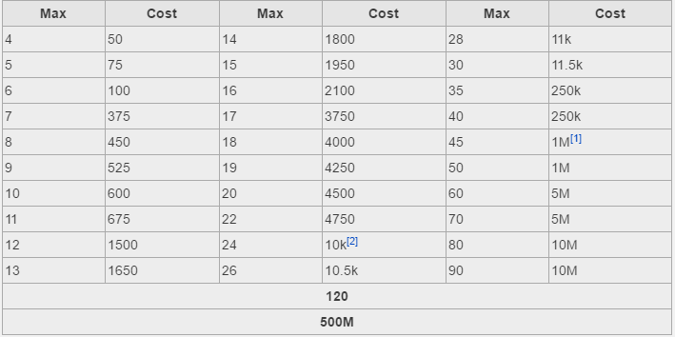A further mechanic in the game that drives revenue is the in shops resources capacity load / bins. When you first play the game each normal resource bin has a capacity of three units, the player can increase the capacity of these bins and thus the resources available for the player to use making items to sell to customers. Once a bin reaches a capacity of thirty the cost of further increases goes up considerably, this is shown in figure 3. After looking at several comments from players such as Kronoan they believe that after reaching a certain amount of capacity it becomes too expensive and almost not worth purchasing, suggesting the in-game gold should be used to make potions for sale instead (Kronoan 2013).

Figure 3

As in the real world over expansion in one direction may or may not be good business.

# Conclusion

I think the customer selecting mechanic is a great idea, whilst I sympathise with Xiviar’s view that this mechanic can be irritating, I believe it brings an element of realism into the game, because not everyone that goes into a store will buy something.

It also makes this part of the game a challenge for the player in that if they choose the wrong customer they may annoy the one they choose and in turn lose other customers due to them waiting too long.

The in game resources mechanic are priced well for the initial start of the game, and they clearly state the difference in value and how they differ in rarity. It would be useful if the player could affect these prices via a sale or a two- for-one offer etc.

I do agree with what Kronoan has to say about the third column of resources being expensive and that there should be an option to pay with in-game gold as well as tokens, which in turn would increase the developer’s revenues by players purchasing gold or players playing the game for a lot longer and in turn earn all the gold required to purchase these resources.

So I can conclude that Swords and Potions is a good game because it is fairly realistic compared to the real world but the in-game purchases need to be a little more appealing because they charge to much for what the player is getting in return.

## References

<http://www.gamezebo.com/2012/01/25/swords-and-potions-review/> 11/11/16 13.10pm

<http://swordsandpotions.wikia.com/wiki/Cooperation_improvement_mechanics> 11/11/16 13:25pm

<http://swordsandpotions.wikia.com/wiki/Improvements> 11/11/16 13:30pm

<http://swordsandpotions.wikia.com/wiki/Browsing_customers_mechanic?action=edit&section=1> 11/11/16 13:45pm

<http://swordsandpotions.wikia.com/wiki/User_blog:JonathanHuff/Today%27s_update>

<https://taogaming.wordpress.com/2011/09/03/swords-and-potions-thoughts-of-real-games/>

<http://swordsandpotions.wikia.com/wiki/Resources>

<http://www.tru.ca/__shared/assets/Critical_Analysis_Template30565.pdf>

**Questions from DAD**

I have added real revenue issues, is what real money the developer gets, do players buy tokens or can they earn them and play the game for free,

This sounds like a multi- person game where players choose their charter att he beginning

There is nothing in the brief to say you have to review the merchant character

You seem to only quote too external references, should you also quote others, mention groups of friends who play

You spend a lot of time describing the game paly, the brief is about the mechanics and how they relate to revenue, I don’t think you need to be so descriptive

Also try to structure you essay, Introduction, Body – with sub headings, Conclusion, try to avoid mixing elements up in this case you talk about marketing and revenue in the same paragraph, as a report these should be separate issues

Always add captions to images

Reference images ?